TASK | Easing/ lubricating fluid used on components and expels water or moisture
LOCATION OF USE | Workshop and field engineers |  | Assessment  No |  | 005
PRODUCT NAME | Maintenance Spray |  |  |  | 005
DESCRIPTION OF SUBSTANCE | De watering fluid |  |  |  | 005
MANUFACTURER | James Briggs Limited  4 Howarth Court,  Gateway Crescent, Chadderton,  Oldham, Lancashire  OL9 9XB  England |  |  |  | 005
MANUFACTURERS CONTACT | 0161 627 0101 |  |  |  | 005
ASSESSOR | Martin Monaghan CMIOSH |  | Date |  | 23 07 24
TITLE | Health and Safety Consultant |  | Review by |  | 23 07 26
Personnel Performing Task  (Please list below)  Technicians/ Fitters/ Workshop Operatives |  | Time Spent  (Minutes/day)  As and when required, amounting to a few minutes per day | Training Given 
 |  |  | Yes

MSDS Revision Date | Hazard Statement
24 03 2014 | H222 Extremely flammable aerosol.  H336 May cause drowsiness or dizziness

Assessment to be conducted in Association with Hazard Data Sheets, a full current copy of which must be attached to this assessment.

Please denote the hazardous properties of the substances used in the task with a

NEW INTERNATIONAL GLOBALLY HARMONISED HAZARD SYMBOLS
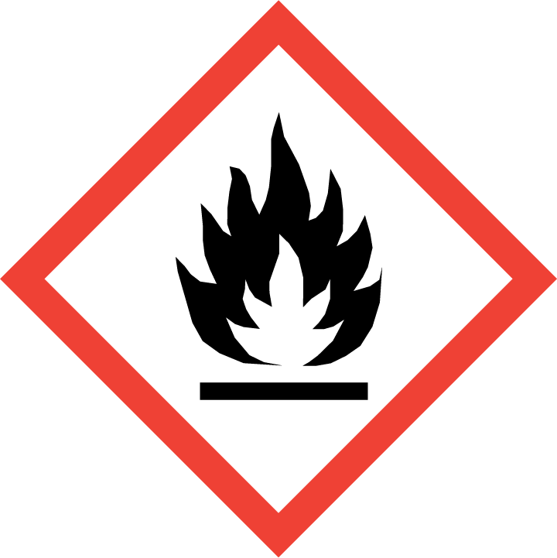 | 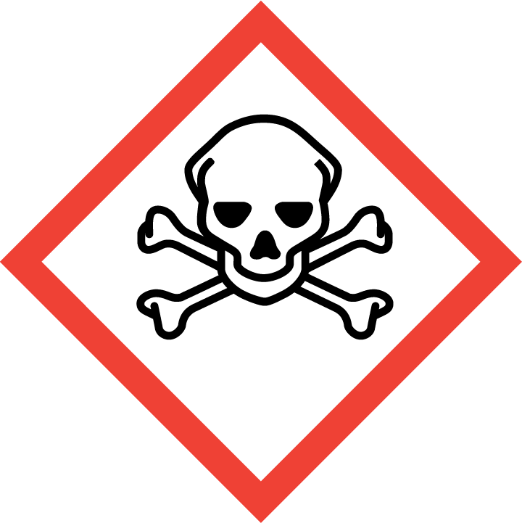 | 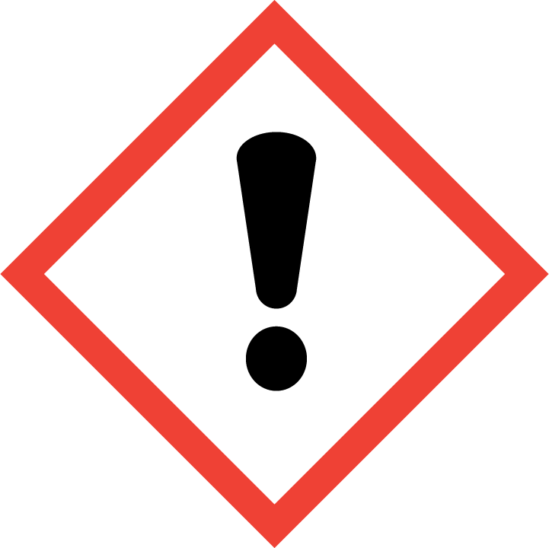 | 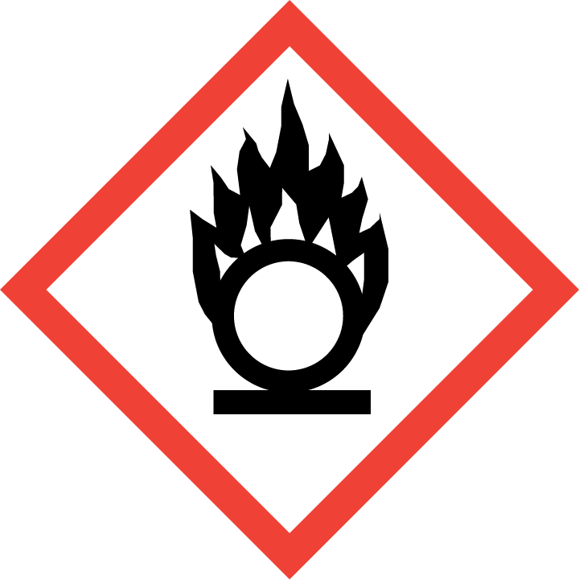 | 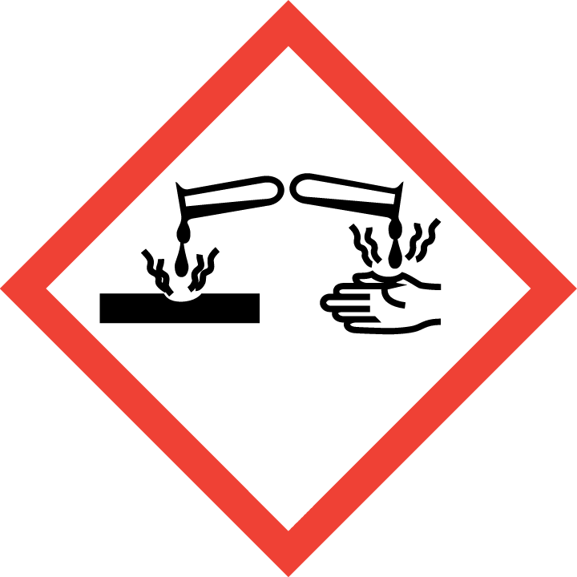 | 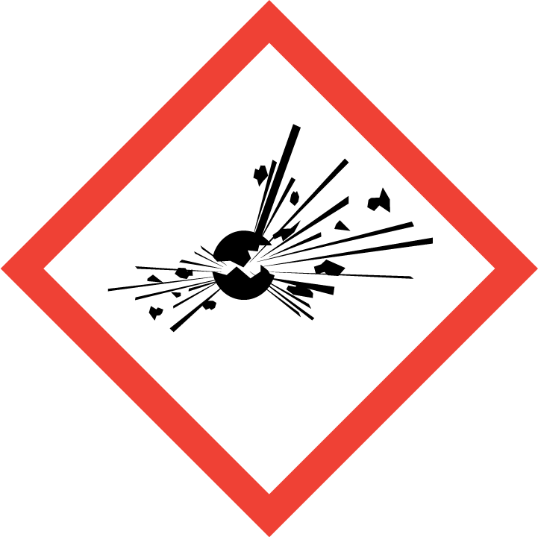 | 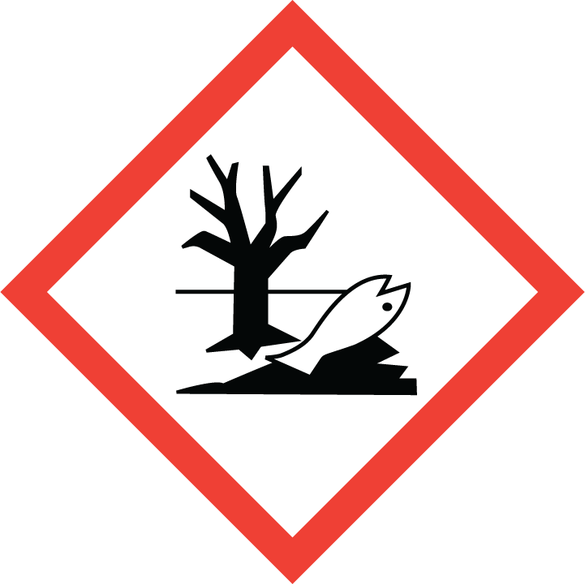 | 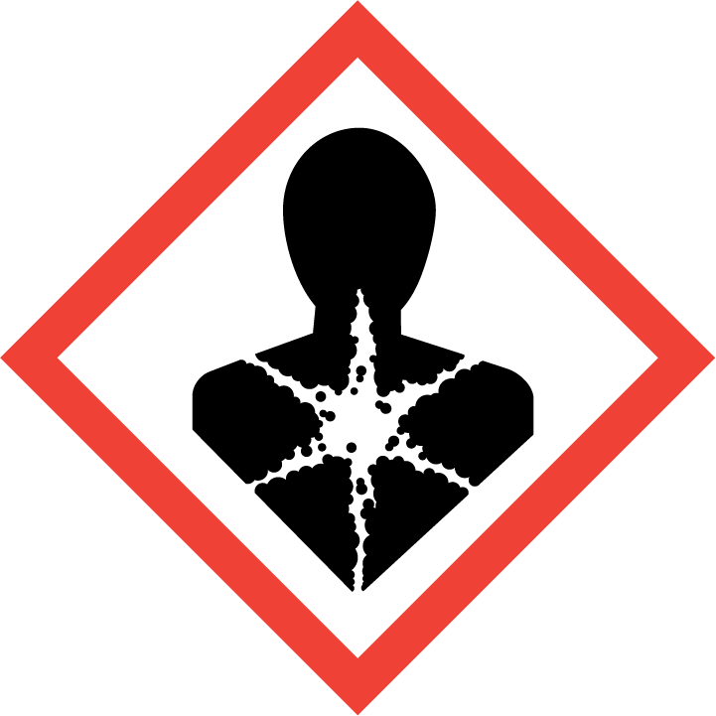
Flammable | Toxic | Harmful | Oxidising | Corrosive | Explosive | Harmful to the environment | Health Hazards i.e. respiratory sensitisation or carcinogenicity

SMOKING, EATING AND DRINKING ARE PROHIBITED IN THE WORK AREAS.
Information, Instruction and Training must be provided to all users. Young Persons, New or Expectant Mothers and other vulnerable groups must not use or be exposed to this product.

WORKPLACE EXPOSURE LIMITS (WEL’s)
The hazardous ingredients in this product which have WEL are:
Hydrocarbons, Carbon dioxide, Oil mist, mineral oil

IMPORTANT!
Refer to Workplace Exposure Levels information provided in the Manufacturers Safety Data and revise control measures if exposure levels likely to be reached.

ROUTE OF EXPOSURE
Skin |  | Eyes |  | Inhalation
Ingestion |  | Cuts/abrasions |  | Systemic

PERSONS AT RISK
User of product |  | Co workers |  | Members of the public

ROUTE OF EXPOSURE |   FIRST AID MEASURES
Eyes | Remove contact lenses. Wash out eye with plenty of water. Obtain medical assistance if soreness or redness persists.
Skin | Remove polluted, soaked clothing immediately. Wash thoroughly with plenty of water and soap. In case of irritation of the skin contact doctor.
Inhalation | No risk from inhalation.
Ingestion | Rinse the mouth thoroughly with water. Do not induce vomiting. Obtain medical attention.
In all cases of doubt, or if symptoms persist seek medical attention. Never give anything by mouth to an unconscious person. If unconscious, place in recovery position and seek medical advice.

PERSONAL PROTECTIVE EQUIPMENT
 |  |  |  | 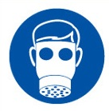 |  | 
YES | YES | YES/NO |  | YES/NO | YES | YES/NO
 |  |  |  |  | Chemical Resistant
Wear glasses if there is a risk of splashing | Normal work wear |  |  | N/A | PVC gloves

HANDLING | STORAGE | TRANSPORT | DISPOSAL
Ensure good ventilation. Do not use on hot surfaces. Observe directions on label and instructions on use. General hygiene measures for the handling of chemicals apply. | Store in cool, well -ventilated area. Keep container tightly closed. | Not classified as hazardous under CHIP or CLP. | Send to registered waste disposal site using services of a registered waste disposal contractor. Disposal of packaging: Dispose of as normal industrial waste.

REQUIRED CONTROL MEASURES
- Users to avoid contact with skin and eyes – Use PPE.
- Ensure operatives are made aware of and understand the purpose of this assessment and MSDS, plus any health implications of using the product.
- Ensure COSHH assessments with accompanying MSDS are made available for all employees and users and for inspection and emergency purpose.
- Carry out personal exposure monitoring.
- Wash promptly if skin becomes contaminated. Wash hands at the end of each work shift and before eating, smoking and using the toilet.

FIRE PRECAUTIONS
Suitable extinguishing agents:
Foam, powder, CO_{2.}

ACCIDENTAL RELEASE/SPILLAGE PROCEDURES
Remove possible causes of ignition. Do not smoke. Ensure sufficient air supply. Wash down floor area as spillage may be slippery. Larger spillage should be contained with sand or earth and collected in salvage container for disposal.
Protect drains from potential spills to minimise contamination. Do not wash product into drainage system. In the case of large spills contact the appropriate authorities. In the case of spillage on water, prevent the spread of product by the use of suitable barrier equipment. Recover product from the surface. Protect environmentally sensitive areas and water supplies. Absorb into dry earth or sand. Protect drains using drain covers. Dispose of any hazardous waste.

MONITORING REQUIREMENTS AND HEALTH SURVEILLANCE
Health surveillance is not in place for workers exposed to this product.

